Title (50-60 characters including spaces):
The Transition to College: Student Voices from the Class of 2023
Authors: Alexandria Hurtt, Michal Kurlaender, Christina Sun, and Baiyu Zhou
Abstract (125 words): This report centers the schooling experiences of the California high school graduating class of 2023, offering insights into their preparation, plans, and concerns about college prior to enrollment. Drawing on results from a large-scale survey of high school seniors, findings reveal important variation in students’ secondary school experiences and their plans for college, particularly by race/ethnicity and gender identity. As students’ experiences in high school academically, socially, and emotionally influence concerns about their college futures, these results represent an important marker of what college-going may look like for future graduating cohorts and enable policymakers and practitioners to better understand the context of students’ postsecondary decisions.
Acknowledgements: The authors are grateful to Scott Carrell, Elizabeth Friedmann, Paco Martorell, and Sherrie Reed for their expertise and support in the construction of the survey, data analysis, and review of findings. The research was supported by the College Futures Foundation and conducted in partnership with the California Student Aid Commission. The California Education Lab at the University of California, Davis and Policy Analysis for California Education are also thankful for research dissemination support from the Bill and Melinda Gates Foundation. The findings and conclusions here are those of the authors alone and do not necessarily reflect the positions or policies of the funders or of the California Student Aid Commission.

Executive Summary
The high school graduating class of 2023 represents yet another cohort of students for whom schooling was marked by unprecedented disruption, characterized by extended remote learning at the onset of high school due to a global pandemic. As such, we surveyed these students about their high school experiences, the support they received, their academic interests, and their concerns about college. This report summarizes findings from a survey distributed to all California high school seniors that submitted financial aid applications for 2023-24. Results reveal important perspectives about students’ experiences and how those differ by a variety of characteristics. Specifically, we find:
- Although nearly 85 percent of California high school graduates of 2023 report having a positive academic experience, this experience differed across student groups.
- Seniors were less likely to view their social experience in high school as positive, with wide variation evident across gender identity.
- Although most students did not experience bullying or harassment in their final year of high school, clear differences emerged across student subgroups. Among those bullied or harassed, most believed they were targets because of their race/ethnicity and/or gender identity.
- Most seniors felt that teachers and staff cared about their future, although fewer students were satisfied with the college advising they received.
- Nearly 63 percent of the seniors surveyed felt prepared for college prior to enrollment.
- Over 38 percent of students planned to enroll in community college, while nearly 44 percent of students planned to attend one of the state’s four-year public universities.
- Engineering, natural sciences, and health sciences were the most popular majors the graduating class of 2023 intended to pursue.
- About 58 percent of students planned to enroll in at least one online college course in the fall.
- Of those that expressed the most concerns about college, students reported apprehension about their academic performance and finding community amongst their peers as the dominant worries.

This work presents varying perspectives about students’ high school experiences and their college hopes and concerns. As students’ experiences in high school influence concerns about their college futures, these results represent an important marker of what college-going may look like for future cohorts and enable policymakers and practitioners to better understand the context of students’ postsecondary decisions.
Introduction
The transition from high school to college can be challenging for students as they begin to navigate both new academic and social environments, with many juggling substantial work and family obligations while in school. This past fall, nearly two-thirds of California high school graduates started college. Given the COVID-19 pandemic, these students spent a significant portion of their early high school years (9th and 10th grade) learning remotely. This report summarizes the findings from a May 2023 survey distributed to California high school seniors who submitted either the Free Application for Federal Student Aid (FAFSA) or the California Dream Act Application (CADAA). We asked students in the high school graduating class of 2023 about their high school experiences, the support they received in preparing for college, their academic interests, and their concerns about college given the unprecedented disruptions in the start of their high school years and the ways the pandemic may have shaped their educational trajectories.
In order to better understand the context of the postsecondary decisions of students on the cusp of college matriculation, this work centers the schooling experiences of the most recent graduating class of California high school seniors, offering insights into their preparation, plans, and concerns about college prior to enrollment. Results illuminate important perspectives about students’ experiences and how those differ by a variety of characteristics. Overall, most students report positive academic experiences in high school. However, a positive academic experience did not always extend to one’s social experience, with nearly one-quarter of students reporting being bullied or harassed at least once in the past year. These experiences in part shape students’ preparation for college. In this case, we find that most students, nearly 63 percent, felt prepared, and about 95 percent of students report planning to attend college in the fall, with the majority of those surveyed planning to enroll in one of the state’s four-year public universities. Students also expressed concerns about what to expect once enrolled in college, including their academic performance and whether they would find community amongst their peers, among other concerns. Across these domains, clear differences emerged by demographic characteristics, particularly race/ethnicity and gender identity.
About the Survey [Call Out Box on Survey Data]
This past spring, the California Education Lab at the University of California, Davis partnered with the California Student Aid Commission (CSAC) to launch a survey to document the experiences of high school seniors who intended to enroll in college. The web-based survey was sent to all high school seniors statewide who submitted federal and state financial aid applications for the 2023-24 academic year. As this was the first year that high school students were required to submit a FAFSA, financial aid applicants may be more representative of the broader population of the graduating class than previous cohorts.
Through Likert-scale survey questions, students reported on varying dimensions of their high school experience and plans for the future. Additionally, in responses to open-ended questions, students described in their own words the challenges and excitements about college they anticipated prior to matriculation. In this report, we present data on the over 10,000 survey respondents who indicated they were high school seniors. Seniors were asked about their high school experiences, college preparedness, as well as their intent to enroll in college in fall 2023. Those that intended to enroll in college (approximately 9,200 seniors) were then asked about their college plans and worries prior to matriculation. We also capture the differences in student experience by self-reported race/ethnicity, gender, and parental education levels. We focus here on findings from the largest subgroups in each of these categories. This follows our prior reports, which document the obstacles college students faced during the pandemic and the great uncertainty high school students expressed about their college futures.
Although the low response rate (4 percent) limits the generalization of these findings to the broader population of high school seniors, the large sample size of respondents (over 10,000 students) nevertheless affords broad diversity in student response. We compare the characteristics of survey respondents to the population of FAFSA submitters (the population from which these respondents were drawn) and to the characteristics of the overall population of the high school seniors of 2023 to ensure broad representativeness among survey respondents (see Note on Table 1).
Sample Characteristics
Table 1 includes the demographic characteristics of our analytical sample by race/ethnicity, gender, and parental education. Survey respondents were more likely to be Latinx (39.8 percent), cisgender women (44 percent), and have parents that had earned a high school diploma (16.7 percent). Despite this, we do note that the level of parent education is more evenly distributed, with about 14 percent of students reporting their parents did not complete high school or earned at least a bachelor’s degree, respectively.

Table 1. Descriptive Statistics of Survey Sample
 |  | Survey Respondents
 |  | N | Percent
Total respondents |  | 10,221
Race/ethnicity
 | American Indian/Alaskan Native/Pacific Islander | 247 | 2.4
 | Asian | 1,163 | 11.4
 | Black/African American | 559 | 5.5
 | Hispanic/Latinx | 4,066 | 39.8
 | Filipino | 244 | 2.4
 | White/Non-Hispanic | 1,553 | 15.2
 | Other | 198 | 1.9
 | Not reported | 2,191 | 21.4
Gender
 | Cisgender woman | 4,503 | 44.1
 | Cisgender man | 2,864 | 28.0
 | Non-binary/Gender variant | 418 | 4.1
 | Unsure/prefer not to say | 191 | 1.9
 | Not reported | 2,245 | 22.0
Parent level of education
 | Did not complete high school | 1,467 | 14.4
 | High school diploma | 1,708 | 16.7
 | Some college, no college degree | 1,023 | 10.0
 | Associate degree | 474 | 4.6
 | Bachelor's degree | 1,394 | 13.6
 | Graduate/professional degree | 1,485 | 14.5
 | Don't know | 447 | 4.4
 | Not reported | 2,223 | 21.8
Note. The survey sample is overrepresented in American Indian/Alaskan Native/Pacific Islander and Black/African American students by about 2 percentage points and Asian students by 5 percentage points, while underrepresented in Hispanic/Latinx students by 5 percentage points compared to the statistics provided by the California Department of Education’s DataQuest for the full cohort of 12th graders attending public high schools in California in 2023. Gender identity data for the survey sample includes different categories than those available through the California Department of Education’s DataQuest, which reports that 48 percent of public high school 12th graders were female, 51.5 percent were male, and less than a half of one percent were non-binary in 2023.
High School Experience
College-going is inherently shaped by the experiences one has while in high school. Schools play an important role in socializing students’ perception of college and future educational attainment (Lynn et al., 2010; Uwah et al., 2008). Key to this is students’ sense of belonging, or how connected students feel to their school or academic community, which is strongly associated with motivation and achievement (Gillen-O’Neel & Fuligni, 2013; Kurlaender et al., 2018; Osterman, 2000; Walton & Cohen, 2007, 2011). Additionally, demographic characteristics, including gender, sexual orientation, and race/ethnicity, also influence students’ social experience, which can impact their sense of belonging in schools (Allen et al., 2018; Graham et al., 2022; Kosciw et al., 2022). Additional evidence suggests that students whose parents have higher levels of educational attainment may experience a stronger sense of belonging, leading to increased academic motivation (Ruedas-Gracia et al., 2020). We asked students to reflect on their high school experience as they neared the end of their senior year. Students considered both their academic and social experiences throughout their high school tenure.
Although nearly 85 percent of recent California high school graduates had a positive academic experience, this experience differed across student groups.
Across our sample, a majority of respondents (84.4 percent) rated their academic experience in high school as good, very good, or excellent, with 24.6 percent rating the experience as excellent (see Figure 1). This suggests that, for the most part, respondents had a positive academic experience in high school; however, clear differences emerged across demographic characteristics. For example, we find that American Indian/Native American, Black, and Latinx students were less likely to answer good or above. Additionally, students whose parents had higher education levels were more likely to report positive academic experiences than their counterparts. Importantly, both race/ethnicity and parental education appear to be highly correlated. Additionally, when we classify students into broad gender categories, we find no clear differences related to academic experience.

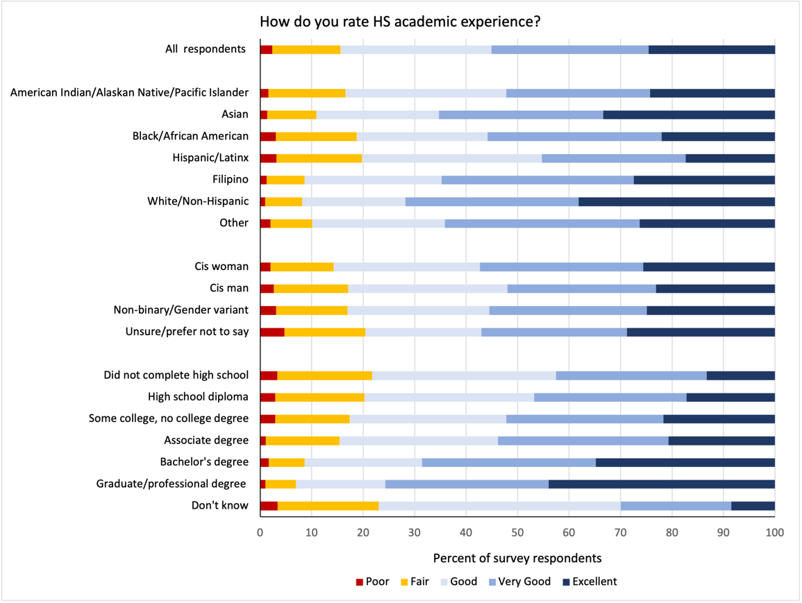
Figure 1. Academic Experience in High School

Note. Rates depicted in the figure represent 8,288 survey respondents who answered this question. Racial/ethnic, gender, and parent level of education subgroups also exclude respondents who did not provide a response for the respective demographic question within the survey.
Seniors were less likely to view their social experience in high school as positive, with wide variation evident across gender identity.
Compared to their academic experience, high school seniors in our sample rated their social experience overall as less positive, with 70.4 percent of respondents rating it as good, very good, or excellent, and less than 12 percent selecting excellent (see Figure 2). In terms of gender, a larger proportion of cisgender men rated their social experiences as positive (74.5), higher than any other gender identity. Conversely, gender variant students and those that are unsure or preferred not to answer, were more likely to report their social experience as fair or poor compared to cisgender men and women. Further, fewer differences emerged across race/ethnicity and parental education.

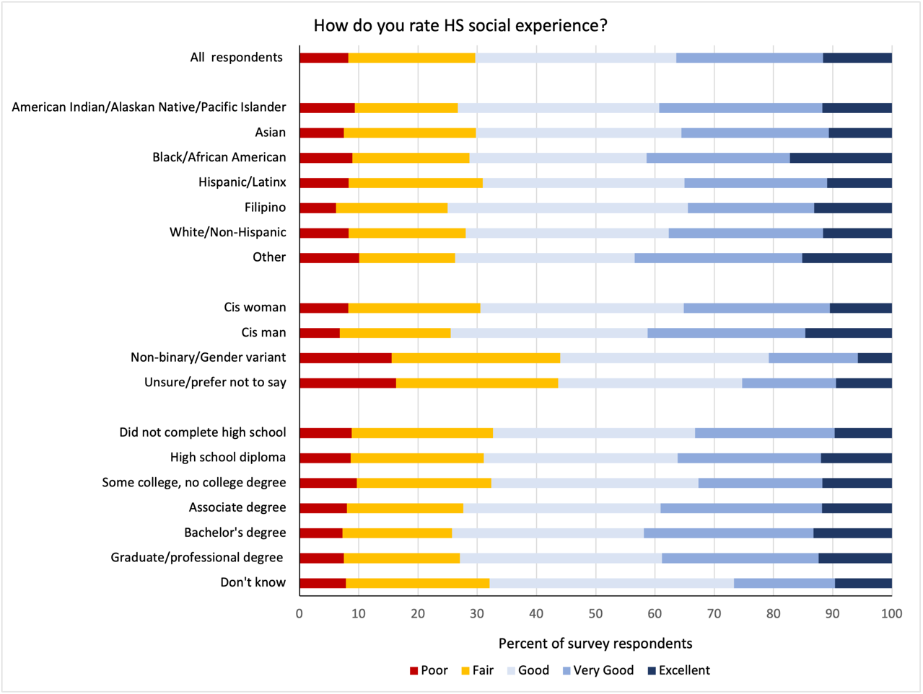
Figure 2. Social Experience in High School

Note. Rates depicted in the figure represent 8,261 survey respondents who answered this question. Racial/ethnic, gender, and parent level of education subgroups also exclude respondents who did not provide a response for the respective demographic question within the survey.
[Quote Call Out Box]
“I think the biggest challenges I’ll face would probably be feeling welcomed and being more social. My biggest fear is feeling as if I’m not welcomed due to my ethnicity or the language I speak.”
Although most students did not experience bullying or harassment in their final year of high school, clear differences emerged across student subgroups.
A critical aspect of school belonging and students’ overall experience in high school is one’s school environment (Slaten et al., 2016), which includes safety. Perceived safety at school is positively associated with belonging (Allen et al., 2018), which lessens if that safety is jeopardized in any way (Whitlock, 2007), such as by bullying or harassment (Renick & Reich, 2021).
Although a majority (76.6 percent) of seniors in our survey cited zero instances of bullying or harassment, nearly one-quarter (23.4 percent) reported being bullied or harassed at least once in the past year and about 13 percent indicated that they experienced repeated bullying or harassment (two instances or more) (see Figure 3). Across demographic characteristics, some groups were also more likely to report experiencing instances of bullying or harassment. For example, we find that almost half of all gender variant students surveyed reported being bullied at least once in the past year (48.2 percent), more than any other group in our study. In contrast, cisgender men reported less incidences of bullying overall (16.5 percent). Experiences with bullying and harassment were also disproportionate across race/ethnicity, as higher rates were reported for American Indian/Alaskan Native (32.9 percent), Filipino (33.3 percent), and White students (28.2 percent). Moreover, Filipino (18.9 percent), American Indian/Alaskan Native (18.3 percent), and gender variant students (34.3 percent) were also more likely to report repeated instances of bullying or harassment overall compared to their counterparts. This aligns with prior research, which finds that gender variant students often face higher rates of harassment and bullying in high school compared to their cisgender peers (Eisenberg et al., 2017; McGuire et al., 2010; Pampati et al., 2020) and that experiences with bullying vary across racial/ethnic groups (Rhee et al., 2017; Xu et al., 2020).
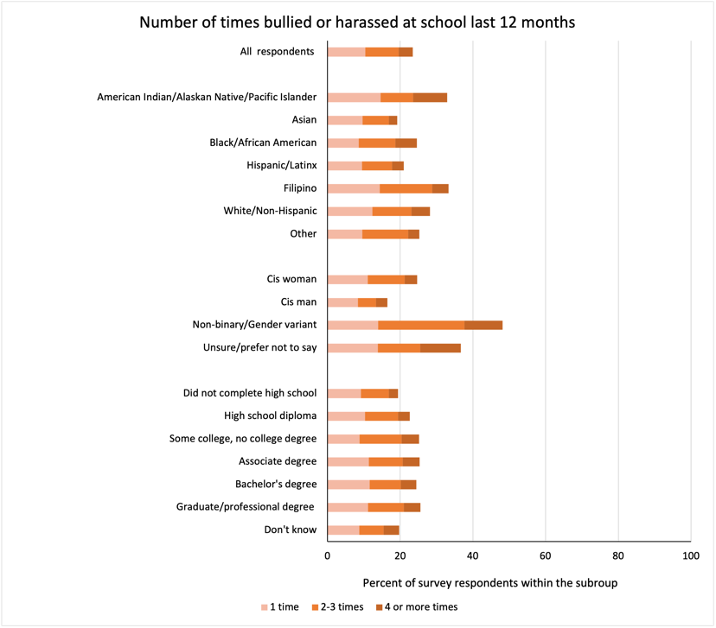
Figure 3. Bullying or Harassment in School in the Last Year

Note. Rates depicted in the figure represent 8,114 survey respondents who answered this question. Racial/ethnic, gender, and parent level of education subgroups also exclude respondents who did not provide a response for the respective demographic question within the survey.
Among students who reported experiencing bullying or harassment, most believed they were targets because of their race/ethnicity and/or gender identity.
To better understand the experiences of students reporting bullying or harassment, we included the follow-up question: During the past 12 months, were you harassed or bullied for any of the following reasons: race or ethnicity; religion; gender identity; sexual orientation? Table 2 presents these results, indicating that most students (51.2 percent) reported that bullying or harassment was based on their race/ethnicity, while 32.6 percent and 12.7 percent indicated they experienced bullying or harassment on the basis of gender or religion, respectively. These experiences were also different across student groups; among gender variant students that responded to this question, 78 percent reported experiencing bullying or harassment because of their gender identity. These findings reflect the most recent GLSEN National School Climate Survey, in which over 76 percent of students experienced verbal harassment specifically based on sexual orientation, gender expression, or gender more generally at some point at school in the past year (Kosciw et al., 2022). Comparatively, cisgender men (66.3 percent) and women (54.1 percent) were more likely to experience bullying or harassment based on race/ethnicity. Moreover, for students of color, including Black (83.3 percent), Filipino (76.9 percent), Asian (66.9 percent), and American Indian/Alaskan Native students (63 percent), race/ethnicity was also reported as a reason they were bullied or harassed in the past year. For White students, the opposite was true, with nearly half of those that responded (49.8 percent) reporting bullying or harassment based on gender. Moreover, students that are White (18.9 percent), cisgender men (16.3 percent) and women (13.7 percent) indicated a higher proportion of bullying and harassment based on religion than rates overall.

Table 2. Reasons for Bullying or Harassment in School
 |  | Reasons for Bullying
 |  | Gender | Race | Religion
All respondents |  | 32.6% | 51.2% | 12.7%
Race/ethnicity
 | American Indian/Alaskan Native/Pacific Islander | 45.7% | 63.0% | 8.7%
 | Asian | 28.5% | 66.9% | 10.8%
 | Black/African American | 19.6% | 83.3% | 5.9%
 | Hispanic/Latinx | 29.9% | 48.8% | 10.9%
 | Filipino | 25.0% | 76.9% | 5.8%
 | White/Non-Hispanic | 49.8% | 20.9% | 18.9%
 | Other | 18.5% | 59.3% | 37.0%
Gender
 | Cis woman | 29.5% | 54.1% | 13.7%
 | Cis man | 8.3% | 66.3% | 16.3%
 | Non-binary/Gender variant | 78.0% | 25.2% | 5.7%
 | Unsure/prefer not to say | 51.2% | 25.6% | 2.3%
Note. Rates depicted in the table represent 1,042 survey respondents who answered this question. Racial/ethnic, gender, and parent level of education subgroups also exclude respondents who did not provide a response for the respective demographic question within the survey. Each cell represents the percent of respondents in that subgroup that reported bullying for a given reason (columns). Numbers do not accumulate across rows because students may report bullying for more than one reason.
College Preparedness
Most seniors felt that teachers and staff cared about their future, although fewer students were satisfied with the college advising they received.
School belonging is also mediated by the relationships between students and school staff, which can lead to better academic outcomes (Hallinan, 2008; Hattie, 2009), including college-going (Lecy, 2021). Reflecting on their perceived support in the transition out of high school, seniors were asked about the care demonstrated by teachers and school staff as well as their experiences with advising. By and large, high school seniors believed that the teachers and staff at their school cared about their future, with nearly 80 percent responding somewhat agree or strongly agree to the statement: Teachers and staff at my high school care about my future (see Figure 4). This high satisfaction rate was shared across race, gender, and parental education level, although rates were slightly disproportionate across race/ethnicity and parental education, with greater rates of Filipino (83.6 percent) and White (82.4 percent) students as well as those whose parents had college degrees more likely to feel that staff cared. However, compared to their perceptions about staff, fewer students were satisfied with the college advising they received, with 66.2 percent indicating somewhat agree or strongly agree to the statement: I received good advising from high school about college (see Figure 5). Further, students with higher parental education were less likely to be satisfied with their college advising.
Figure 4. Care from Teachers and Staff about Students’ Futures
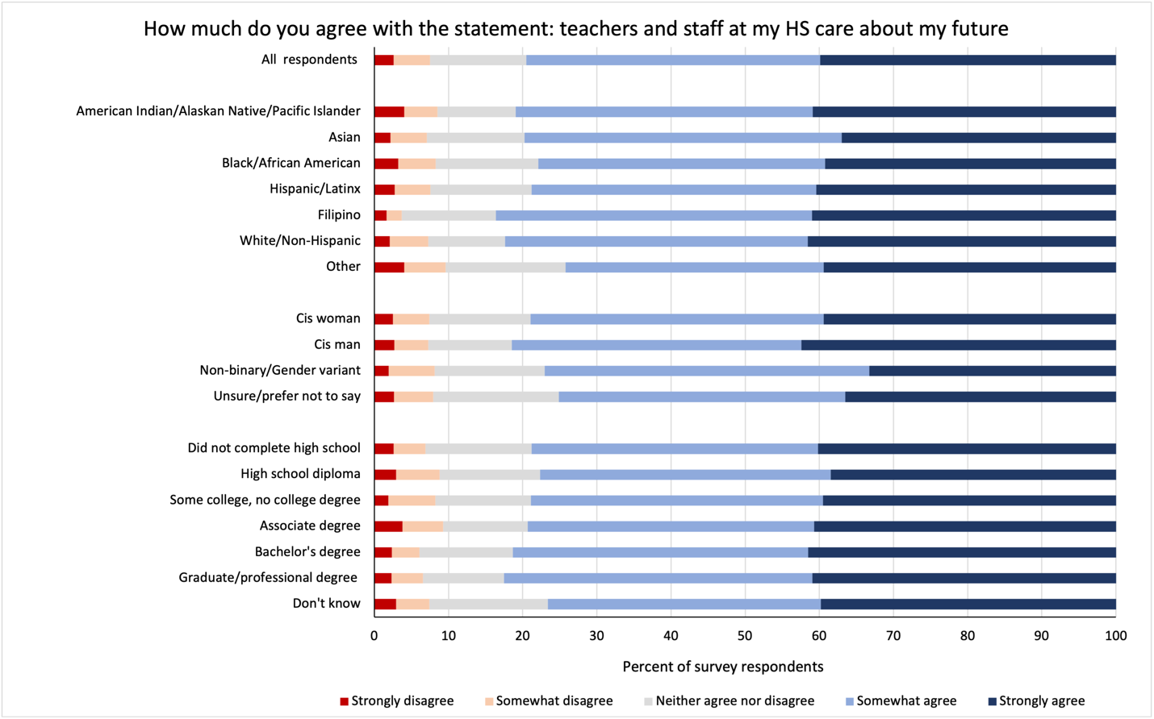

Note. Rates depicted in the figure represent 8,135 survey respondents who answered this question. Racial/ethnic, gender, and parent level of education subgroups also exclude respondents who did not provide a response for the respective demographic question within the survey.

Figure 5. College Advising in High School
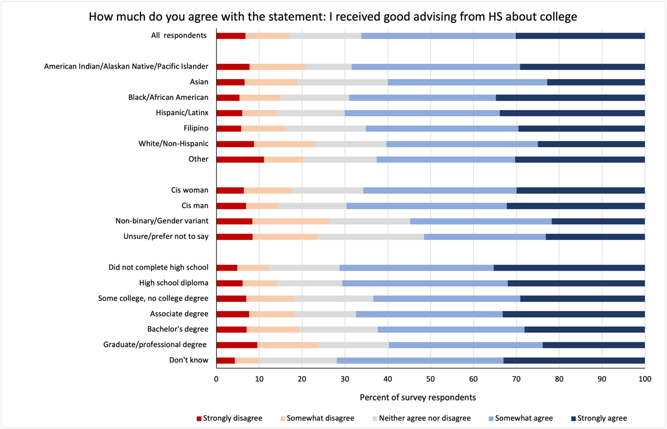

Note. Rates depicted in the figure represent 8,137 survey respondents who answered this question. Racial/ethnic, gender, and parent level of education subgroups also exclude respondents who did not provide a response for the respective demographic question within the survey.
[Quote Call Out Box]
“I believe remaining consistent [with] my academics will [be] the biggest challenge. I personally don’t believe I’m prepared to pass college level classes. Yet I notice… Most of [the] class of 2023, aren’t prepared as well.”
Nearly 63 percent of the seniors surveyed felt prepared for college prior to enrollment.
Figure 6 presents results on students’ readiness for college. Generally, seniors felt prepared for college, as 62.6 percent reported that they somewhat agree or strongly agree with the statement: I feel prepared for college, with 21.1 percent indicating they strongly agree they felt prepared. Additionally, results reveal that White (27.8 percent), cisgender men (23.8 percent) were more likely to strongly agree they were prepared compared to their race and gender counterparts. Moreover, higher parental education is also associated with increased college preparedness. Therefore, while satisfaction with advising declines as parental education increases, subjective college preparedness rises at higher levels of parental education; this suggests that many students receive help from their parents when applying for college, perhaps more than from their school.

Figure 6. College Preparedness

Note. Rates depicted in the figure represent 8,133 survey respondents who answered this question. Racial/ethnic, gender, and parent level of education subgroups also exclude respondents who did not provide a response for the respective demographic question within the survey.
[Quote Call Out Box]
“[The biggest challenge will be] being away from home. I’m excited to be leaving, but everything I’ve loved my entire life is staying here. My family, my pets, my friends. It hurts knowing people change after high school and my biggest fear is my friends [will] stop keeping in contact with me because I’m moving 12 hours up North.”
College Plans
Over 38 percent of students planned to enroll in community college, while nearly 44 percent of students planned to attend one of the state’s four-year public universities.
An overwhelming majority—nearly 90 percent of the students in our sample—reported that they planned to attend a college in state in the fall of 2023 (see Figure 7). Most students (38.4 percent) intended to matriculate to one of the state’s 116 community colleges, while about 22 percent of students planned to attend a California State University (CSU) or University of California (UC), respectively. Additionally, a little over 10 percent of respondents noted their intention to attend a college outside of California.
Differences also emerge across demographic characteristics. For example, while the majority of Latinx students (46.6 percent) planned to enroll in a community college in the fall, the majority of Asian students (43.3 percent) planned to attend a UC. Relatedly, White (22.1 percent), Black (13.9 percent), Asian (13.2 percent), and students from other racial/ethnic groups (13.2 percent) also indicated plans to enroll in a college outside of California at higher rates. We also note slight differences in enrollment by gender identity, as gender variant students (12.8 percent) were more likely to pursue enrollment at a postsecondary institution outside of California than their counterparts. Similar to college preparation, parent education level was also associated with students’ college plans—the higher level of parent education, the more likely a student reported their plans to enroll in a UC. Moreover, students whose parents had earned a bachelor’s (16.4 percent) or graduate degree (24.9 percent) were also more likely to report plans to attend a college outside of California.

Figure 7. College Enrollment Plans
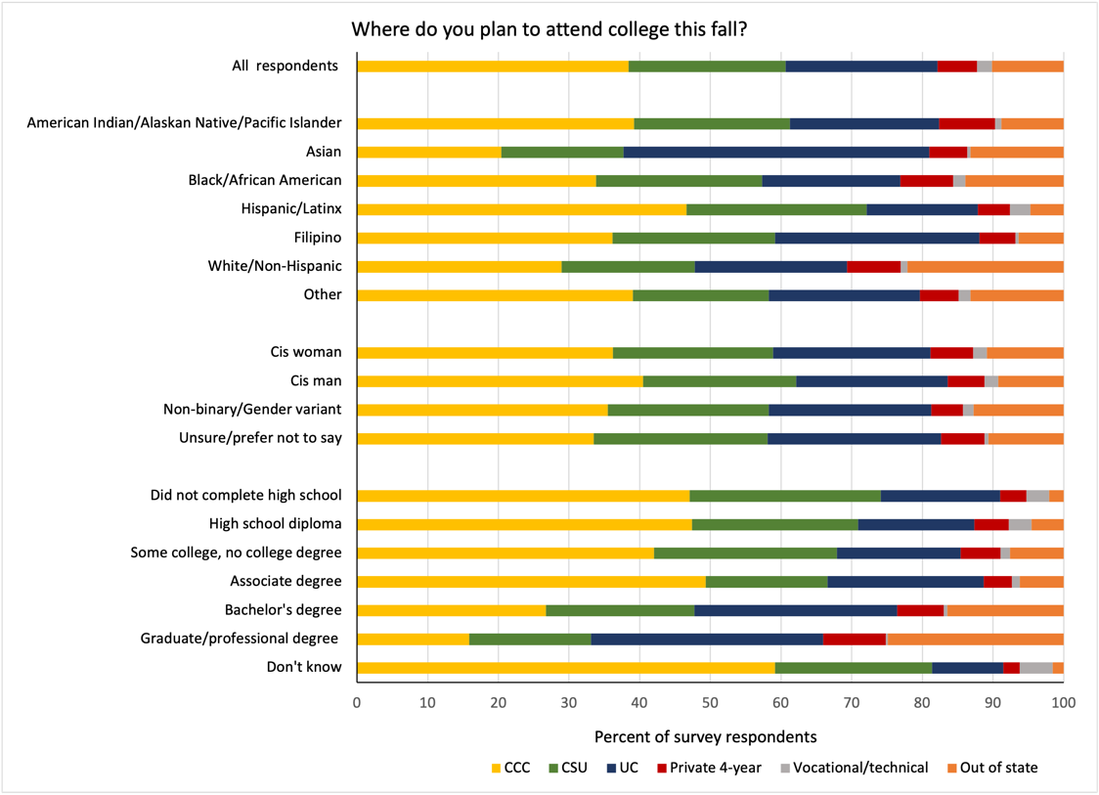

Note. Rates depicted in the figure represent 9,172 survey respondents who indicated plans to attend college and provided answers to the respective demographic question within the survey. Of the full survey sample (n = 10,221), 9,230 respondents indicated they planned to go to college, 170 said they did not plan to attend college, 394 respondents expressed they didn’t know, and 527 students did not respond to the question.
Engineering, natural sciences, and health sciences were the most popular majors the graduating class of 2023 intended to pursue.
Students were also asked what field of study they anticipated pursuing in college (see Table 3). Overall, most students planned to major in engineering (16.0 percent), natural sciences (15.7 percent), and health sciences (15.0 percent). Although these three majors were highly selected across racial and ethnic groups, we observe some differences by subgroups. For example, among Asian students, engineering (26.7 percent) and natural sciences (23.6 percent) were more likely to be selected, while Filipino students were more likely to note health sciences as their intended major (21 percent). Plans for fields of study in college also differed by gender; notably, among cisgender men, 30 percent planned to study engineering—nearly 10 percentage points higher than any other gender identity we surveyed. In contrast, 27 percent of gender variant students were more likely to select humanities and the arts for future study, a rate far and above the overall rate for that major (11.3 percent). We also find that, among students whose parents have earned bachelor’s and graduate degrees, students were more likely to select engineering and natural sciences. Comparatively, students whose parents had received an associate’s degree, high school diploma, or did not complete high school were more likely to indicate a health science major (19.1 percent, 17.9 percent, and 17.5 percent, respectively). Additionally, it is also worth noting that very few students planned to major in education (3.5 percent) or applied sciences (3.4 percent). However, cisgender women were more likely to select education as their intended major compared to their counterparts.
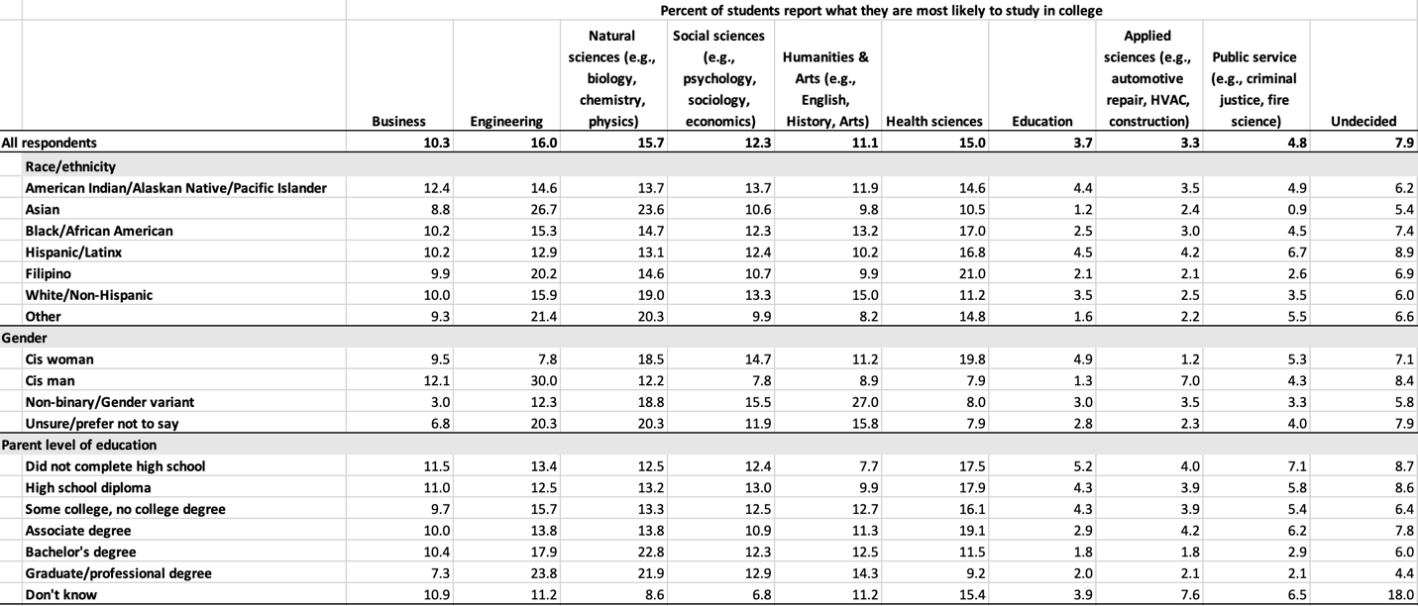
Table 3. Intended College Major

Note. Rates depicted in the figure represent 8,815 survey respondents who answered this question. Racial/ethnic, gender, and parent level of education subgroups also exclude respondents who did not provide a response for the respective demographic question within the survey.
[Quote Call Out Box]
“I think transportation is going to be my biggest challenge. I live 40 minutes away[,] which makes me a little anxious and I’m not exactly sure how it’s going to go which is the reason why I’m planning on taking half of my classes online and the rest in person to make things a bit easier for me.”
About 58 percent of students planned to enroll in at least one online college course in the fall.
Given students’ prior experience with remote instruction during the pandemic, and the increasing online offerings across colleges and universities, we asked students whether they planned to take any college courses online. Results indicate that about 58 percent of seniors intended to take at least one class online, with the majority noting that they planned to take one or two classes (43.5 percent) while only about 2 percent planned to take all of their classes remotely (see Figure 8). While largely similar across gender, results slightly differ by race/ethnicity and parental education; in this case, White students and students whose parents have earned at least a bachelor’s degree are less likely to include online classes in their postsecondary plans compared to their peers. In fact, this was particularly true for seniors whose parents had earned a graduate degree, who had the lowest rates of online course-taking plans overall (44.6 percent).
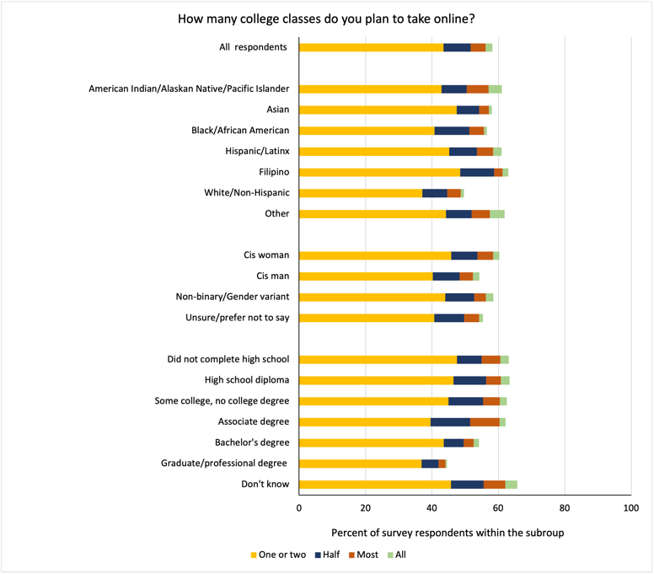
Figure 8. Planned Enrollment in Online College Courses

Note. Rates depicted in the figure represent 7,904 survey respondents who answered this question. Racial/ethnic, gender, and parent level of education subgroups also exclude respondents who did not provide a response for the respective demographic question within the survey.
[Quote Call Out Box]
“One of the biggest challenges might come with the fact that I am not an American citizen and since I am going to a school w[h]ere there [are] primarily [A]merican students. I worry that I will not be taken as seriously. Additionally I am not wealthy or economically affluent and so I worry that during college I will not be able to pay everything I need to or I will be singled out because I will not be able to pay [for] some privileges[,] like going to parties or social events.”
“I think the biggest challenge I’ll face in college is balancing family obligations and studying. Since freshman year in high school, I’ve been the primary caretaker of my nephew. Money has always been tight so we haven’t had the means of finding a daycare service… I’m planning to go home every other weekend to help out with child care, help my mom with her job, and go to Mexico to help my uncles with their business. I know it’s going to be difficult to find a balance but it’s a fact of my life that is nonnegotiable and I will have to find a way to work through this.”
“My biggest challenge that I think I will come across is trying to figure out who I am and what I want to be for myself in the future.”
Concerns about College
Of those that expressed the most concerns about college, students reported apprehension about their academic performance and finding community amongst their peers as the dominant worries.
As the transition to college includes a host of new experiences, we asked respondents about their level of concern across several factors (i.e., academics, family, community, being away from home, mental health support, discrimination) and present these results in Figure 9. By and large, students were not very worried about certain aspects of college; for example, most students had few concerns about discrimination based on religion (83.8 percent), gender (71.3 percent), or race/ethnicity (64.6 percent). Despite this, among the seniors we surveyed, some students were very worried about their academic performance in college (18.9 percent), whether or not they would find community (16.3 percent), if they would have adequate support for their emotional and mental health needs (11.6 percent), how they would balance family obligations (10.6 percent), and living away from home (9.7 percent).

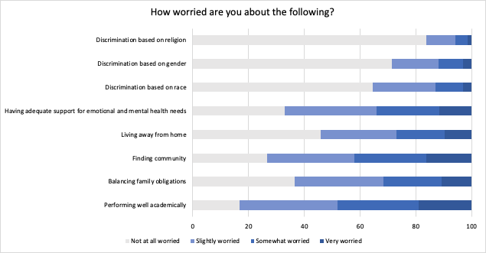
Figure 9. Concerns about College

Note. Rates depicted in the figure represent the survey respondents who answered each of the questions about worry. Academic performance (n = 7,958); balancing family obligations (n = 7,941); finding community (n = 7,934); living away from home (n = 7,948); support for mental health (n = 7,944); discrimination based on race (n = 7,895); discrimination based on gender (n = 7,886); discrimination based on religion (n = 7,891).
For the most part, regardless of race/ethnicity or level of parent education, students were worried about their academic performance more than any of the other factors we listed (see Table 4); although, for Filipino students and seniors whose parents had earned a college degree, this concern was secondary to finding community. In terms of gender, among gender variant students, concerns were relatively equal across several areas, including worries about discrimination based on gender (26.5 percent), the availability of adequate emotional and mental health support (26.3 percent), opportunities to find community (25.3 percent), and academic performance (22.8 percent). It is worth noting that, for these students, it seems that factors that supported a sense of belonging and safety on college campuses came before concerns about academics. In contrast, both cisgender women and men were more concerned about their academic performance in college (20.8 percent and 14.9 percent, respectively). Moreover, while a smaller share of students overall indicated that they were worried about discrimination, 9.6 percent of Black students also expressed concerns about discrimination based on race—more than any other student group surveyed.

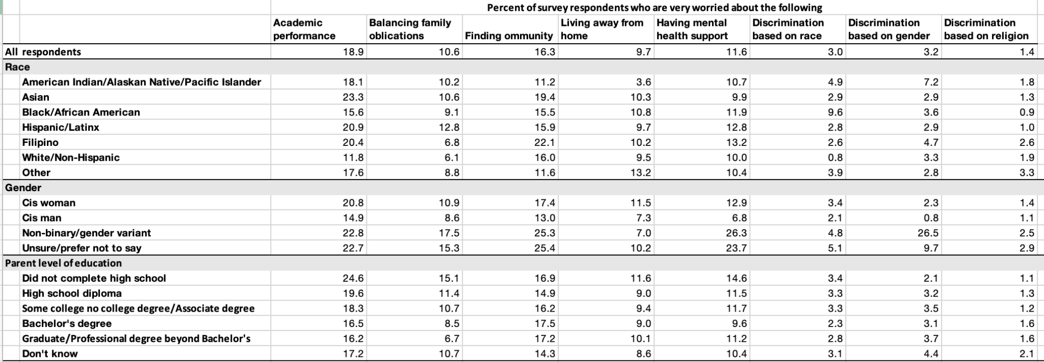
Table 4. Detailed Concerns about College

Note. Rates depicted in the figure represent the survey respondents who answered each of the questions about worry. Academic performance (n = 7,958); balancing family obligations (n = 7,941); finding community (n = 7,934); living away from home (n = 7,948); support for mental health (n = 7,944); discrimination based on race (n = 7,895); discrimination based on gender (n = 7,886); discrimination based on religion (n = 7,891). Racial/ethnic, gender, and parent level of education subgroups also exclude respondents who did not provide a response for the respective demographic question within the survey.
Excitement for College: Student Voice
In a separate open-ended question, seniors were asked: “What are you most excited about for college?” Students described a range of aspects about college-going that they anticipated, many of which were underscored by their newness. Broadly, students were looking forward to new experiences, including meeting new people and learning new things. One student described, “I am [the] most excited for the things I’ll learn and discover and the people I’ll meet along the way.” Several students also considered their upcoming matriculation as an opportunity for “a new chapter”, “a fresh start”, and “new beginnings”, suggesting this would be more than a simple transition from one schooling institution to another—it would be, perhaps unsurprisingly, a turning point in their lives. Moreover, much of this excitement was related to the people they hoped to encounter and relationships they looked forward to building. For example, one student noted:
“I am most excited [about] meeting new people with a wide variety of new perspectives. I love learning new things and I think learning more about the world through people is very important.”
Relatedly, another student voiced:
“I am the most excited to learn in a community that truly values learning and be able to build a community for myself where I truly feel that I belong.”
This learning also extended to personal growth, as one student anticipated “finding [them]self” in college while another was excited to “grow in the education [they would] receive and see... the person [they would] become throughout college.”
Students also touched on the fact that this moment extended beyond their experiences alone, with several seniors mentioning their parents in relation to their own excitement. One student, who self-identified as a first-generation college student in their response, wanted to “make [their] parents proud”, while another said they were looking forward to “being able to get the education my parents never could.” The excitement students described thus captured multiple facets of college-going, including new opportunities academically, socially, and personally that could be shared amongst family. In the words of one student:
“I am excited to explore student life as independently as I can. I want to really feel what it may be like to be an active student on the go, or even on the slow. I am excited to achieve academic heights and experience a school life where I have the choice to control certain variables like class and schedule, and work to better understand and establish my own work ethic. Most of all I am excited to make the most of my college experience, meet new people, and learn from new perspectives.”
Conclusion
The high school graduating class of 2023 represents yet another cohort of students for whom schooling was marked by unprecedented disruption, characterized by extended remote learning at the onset of high school due to a global pandemic. As such, the experience of these students, and how this may have shaped their plans and preparation for college, represents an important marker of what college-going may look like for future graduating cohorts. To better understand the learning context and readiness of these students, this work reports the results of a large-scale survey of California high school seniors that intended to enroll in college in the fall of 2023. Results reveal varying student perspectives about their high school experiences and their college hopes and trepidations. Given California’s significant investments in students’ mental health (DHCS, 2023), these results also suggest such investments are an important undertaking—particularly as students’ experiences in high school academically, socially, and emotionally color concerns about their college futures. In forthcoming work, we delve more deeply into students’ cost considerations, college affordability, and experiences with financial aid processes.

References
Allen, K., Kern, M. L., Vella-Brodrick, D., Hattie, J., & Waters, L. (2018). What schools need to know about fostering school belonging: A meta-analysis. Educational Psychology Review, 30, 1–34. https://doi.org/10.1007/s10648-016-9389-8
Austin, G., Hanson, T., Bala, N., & Zheng, C. (2023). Student engagement and well-being in California, 2019–21: Results of the Eighteenth Biennial State California Healthy Kids Survey, grades 7, 9, and 11. WestEd. https://data.calschls.org/resources/18th_Biennial_State_1921.pdf
Department of Health Care Services (DHCS). (2023). Children and youth behavioral health initiative. https://www.dhcs.ca.gov/cybhi
Eisenberg, M. E., Gower, A. L., McMorris, B. J., Rider, G. N., Shea, G., & Coleman, E. (2017). Risk and protective factors in the lives of transgender/gender nonconforming adolescents. Journal of Adolescent Health, 61(4), 521–526. https://doi.org/10.1016/j.jadohealth.2017.04.014
Gillen-O’Neel, C., & Fuligni, A. (2013). A longitudinal study of school belonging and academic motivation across high school. Child Development, 84(2), 678–692. https://doi.org/10.1111/j.1467-8624.2012.01862.x
Graham, S., Kogachi, K., & Morales-Chicas, J. (2022). Do I fit in: Race/ethnicity and feelings of belonging in school. Educational Psychology Review, 34(4), 2015–2042. https://doi.org/10.1007/s10648-022-09709-x
Hallinan, M. T. (2008). Teacher influences on students' attachment to school. Sociology of Education, 81(3), 271–283. https://doi.org/10.1177/003804070808100303
Hattie, J. (2009). Visible learning: A Synthesis of Over 800 Meta-Analyses Relating to Achievement. Corwin.
Horowitz, J. M., & Graf, N. (2019). Most U.S. teens see anxiety and depression as a major problem among their peers. Pew Research Center. https://www.pewresearch.org/social-trends/2019/02/20/most-u-s-teens-see-anxiety-and-depression-as-a-major-problem-among-their-peers
Kosciw, J. G., Clark, C. M., & Menard, L. (2022). The 2021 national school climate survey: The experiences of LGBTQ+ youth in our nation’s schools. New York: GLSEN. https://www.glsen.org/sites/default/files/2022-10/NSCS-2021-Full-Report.pdf
Kurlaender, M., Reed, S., Cohen, K., Naven, M., Martorell, P., & Carrell, S. (2018, December). Where California high school students attend college. Policy Analysis for California Education, Stanford University, Palo Alto, California. https://edpolicyinca.org/sites/default/files/Statewide percent20NSC percent20Report percent20Final percent20Online.pdf
Lecy, N. (2021). The role of relationships and sense of belonging among first-generation, low-income youth on future college entrance. Social Psychology of Education, 24, 679–689. https://doi.org/10.1007/s11218-021-09625-y
Lynn, M., Bacon, J. N., Totten, T. L., Bridges III, T. L., & Jennings, M. (2010). Examining teachers’ beliefs about African American male students in a low-performing high school in an African American school district. Teachers College Record, 112(1), 289–330. https://doi.org/10.1177/016146811011200106
Martinez, M. N., Cuellar, M. G., Reed, S., & Esposito-Noy, C. (2023). Enlace comunitario: Identifying opportunities to enhance community college outreach and recruitment of Latinx/a/o students. Wheelhouse: The Center for Community College Leadership and Research, University of California, Davis. https://education.ucdavis.edu/sites/main/files/mark_wheelhouse_research_brief_vol_8_n_2_final_2.pdf
McGuire, J. K., Anderson, C. R., Toomey, R. B., & Russell, S. T. (2010). School climate for transgender youth: A mixed method investigation of student experiences and school responses. Journal of Youth and Adolescence, 39, 1175–1188. https://doi.org10.1007/s10964-010-9540-7
Osterman, K. F. (2000). Students’ need for belonging in the school community. Review of Educational Research, 70(3), 323–367. https://doi.org/10.2307/1170786
Pampati, S., Andrzejewski, J., Sheremenko, G., Johns, M., Lesesne, C. A., & Rasberry, C. N. (2020). School climate among transgender high school students: An exploration of school connectedness, perceived safety, bullying, and absenteeism. The Journal of School Nursing, 36(4), 293–303. https://doi.org/10.1177/1059840518818259
Reber, S., & Smith, E. (2023). College enrollment disparities: Understanding the role of academic preparation. Brookings. https://www.brookings.edu/wp-content/uploads/2023/02/20230123_CCF_CollegeEnrollment_FINAL2.pdf
Renick, J., & M Reich, S. (2021). Best friends, bad food, and bullying: How students’ school perceptions relate to sense of school belonging. Journal of Community Psychology, 49(2), 447–467. https://doi.org/10.1002/jcop.22471
Rhee, S., Lee, S. Y., & Jung, S. H. (2017). Ethnic differences in bullying victimization and psychological distress: A test of an ecological model. Journal of Adolescence, 60, 155–160. https://doi.org/10.1016/j.adolescence.2017.07.013
Ruedas-Gracia, N., Lafromboise, T., Hussain, S.F., Malik, S.S., & Laverdure, A. (2020). Parent educational level and motivation among Native American adolescents: The mediating role of school belonging. Journal of American Indian Education 59(2), 121–145. https://doi.org/10.1353/jaie.2020.0012.
Slaten, C. D., Ferguson, J. K., Allen, K. A., Brodrick, D. V., & Waters, L. (2016). School belonging: A review of the history, current trends, and future directions. The Educational and Developmental Psychologist, 33(1), 1–15. https://doi.org/10.1017/edp.2016.6
Uwah, C. J., McMahon, H. G., & Furlow, C. F. (2008). School belonging, educational aspirations, and academic self-efficacy among African American male high school students: Implications for school counselors. Professional School Counseling, 11(5), 296–305. https://doi.org/10.1177/2156759X0801100503
Walton, G. M., & Cohen, G. L. (2011). A brief social-belonging intervention improves academic and health outcomes of minority students. Science, 331(6023), 1447–1451. https://doi.org/10.1126/science.1198364
Walton, G. M., & Cohen, G. L. (2007). A question of belonging: Race, social fit, and achievement. Journal of Personality and Social Psychology, 92(1), 82–96. http://dx.doi.org/10.1037/0022-3514.92.1.82
Whitlock, J. (2007). The role of adults, public space, and power in adolescent community connectedness. Journal of Community Psychology, 35(4), 499–518. https://doi.org/10.1002/jcop.20161
Xu, M., Macrynikola, N., Waseem, M., & Miranda, R. (2020). Racial and ethnic differences in bullying: Review and implications for intervention. Aggression and Violent Behavior, 50, 101340. https://doi.org/10.1016/j.avb.2019.101340
YouScience. (2023). Gender diversity in k-12 education and career readiness: Post-graduation readiness gender report. https://resources.youscience.com/rs/806-BFU-539/images/2023_PostGraduationReadinessReport_PartTwo.pdf

Author Biographies

Alexandria Hurtt is a research fellow with the California Education Lab in the School of Education at the University of California, Davis.
Michal Kurlaender is professor of educational policy at the University of California, Davis, faculty director of the California Education Lab, and faculty co-director of Policy Analysis for California Education.
Christina Sun is a PhD student in the Department of Economics at the University of California, Davis and a student affiliate of California Education Lab.
Baiyu Zhou is a PhD candidate in the Department of Economics at the University of California, Davis and a student affiliate of California Education Lab.

Overall, college-going rates for California high school students have remained relatively steady over time, if not modestly increasing, until the pandemic. The California Department of Education reports that statewide college enrollment for the most recent year of publicly available data (2020-21) was 62.2 percent, which still reflects the declines of the pandemic; despite some rebound, these rates have not hit pre-pandemic levels that were at their height in 2018 at nearly 68 percent.
Recently released surveys on high school students’ experiences tend to draw on a narrow sample of students (YouScience, 2023), students predominantly enrolled in earlier grades (Austin et al., 2023; Kosciw et al., 2022; Reber & Smith, 2023), or data collected pre-pandemic (Horowitz & Graf, 2019).
It is important to note that not every high school senior in our sample answered every survey question. This may be for several reasons; for example, a respondent may intentionally ignore certain questions, could forget to answer a question, or may perceive a question to be inapplicable. In this case, as missing data in our results appeared to be missing at random, with some students not responding to questions about demographic characteristics, any missing data is excluded from the present analysis.
Presently, this work reports on broadly defined race/ethnicity and gender categories. In forthcoming work, we explore these results through a more detailed lens, capturing a greater diversity of gender identities as well as sexual orientation in addition to race/ethnicity.
Notably, this rate is somewhat lower (by four percentage points) than the rate reported among 11th graders in the 2017-19 California Healthy Kids Survey (CHKS).
The biennial National School Climate Survey, conducted by GLSEN, documents the schooling experiences of lesbian, gay, bisexual, transgender, and queer (LGBTQ+) students and the impact of these experiences on students’ educational outcomes and well-being. Results from the 2021 National School Climate Survey reflect respondents in grades 6-12, with the largest numbers in grades 9, 10, and 11 (Kosciw et al., 2022).
This is about 20 percentage points higher than results from the 2019-21 CHKS, in which only 60 percent of 11th graders felt that teachers and staff cared. However, in the present survey, the statement students reflected upon included the qualifier “care about my future”, whereas the statement included in the 2019-21 CHKS reads: “At my school, there is a teacher or some other adult who really cares about me.”
For the sections that capture students’ college plans and concerns about college, results reflect the students that reported their intent to enroll in college in the fall after graduation (n = 9,230). Additionally, although high school students were required to submit a FAFSA, and thus financial aid applicants may be more representative of the broader population of the graduating class than previous cohorts, self-selection may nevertheless play a role in our high rates for college plans. This is particularly due to how students were notified of the survey—through several emails sent by the state agency responsible for administering financial aid programs for students in California—and the intrinsic factors (i.e., motivation) that guide decision-making, including survey response. Additionally, plans to enroll in college do not necessarily equate to actual enrollment; in this case, they reflect a student’s intention to matriculate in May of their senior year.
This differs from prior work conducted by the authors on the postsecondary destinations of California high school students. In this case, historically, more California high school graduates tend to enroll in one of the state’s community colleges compared to a four-year university. In fact, our previous report finds that, among college enrollees, 57 percent and 28 percent of students enrolled in a community college or a four-year in-state university, respectively (Kurlaender et al., 2018). In more recent work that examined the college enrollment patterns of Latinx high school students in California, results revealed that, statewide, 37 percent of Latinx students enrolled in a community college in the fall after graduation, while about 18 percent enrolled in a UC or CSU (Martinez et al., 2023).
This survey was administered in May 2023, prior to recent events that have left many concerned about antisemitism and Islamophobia on college campuses.

